Web Appendix

Charities Can Increase the Effectiveness of Donation Appeals by Using a Morally Congruent Positive Emotion

SHREYANS GOENKA
STIJN M.J. VAN OSSELAER

This web appendix provides detailed descriptions for all study procedures. It also includes all wording for manipulations and results for pretests and manipulation checks. Finally, it includes details for supplementary studies.

RESEARCH METHODS DETAILS

Methodology
Study 1 is a field experiment. Study 2-5 are experiments conducted using online surveys

Researcher Characteristics
The first author is a Ph.D. Student in the marketing department. The second author is Associate Dean for Academic Affairs and Professor of Marketing. Data for Study 1 were collected by the manager of the Grocery store (location of field experiment). Researchers had no interaction with the participants. Data for Studies 2-5 were collected by the first author on Amazon MTurk. All data were analyzed by the first author. The second author supervised the data collection and data analysis.

Context
For all experiments, we report all experimental conditions and all manipulations. Details for each experiment are available in the individual web-appendices (see below).

Sample
In study 1, the data collection time-period was fixed (2 weeks) for each condition. Hence, shoppers in the store who voluntarily participated in the donation program in that time period were included in the sample.
For Study 2-5, the sample size was determined in advance, and the fixed number of respondents were recruited on Amazon MTurk. No participants were excluded in any of the studies.

Data Collection Procedures
Details for all study materials are provided in individual web-appendixes (see below)

Post-Data Screening
No participants were excluded. We included all participants in each condition.

Data Description
Data description for each study is provided in the study results section in the main manuscript

Participant Rights
All data were collected after receiving an exemption status from Cornell University research ethics committee (Protocol #: 1710007491). All data collected were anonymous and no specific participant identifiers were collected.

DATA ANALYSIS DETAILS

Study 1
This study utilized a series of Chi-Square tests to analyze the choice data. The manuscript reports the degrees of freedom, Wald statistics, and p values.

Study 2 and 3
These studies utilized Zero-inflated Poison regressions to analyze the donation data.

Study 4
This study utilized PROCESS Model 4 in SPSS to analyze the mediation pathway. 5000 bootstraps were utilized. The manuscript reports the t statistics, p values, and confidence intervals for all pathways.

Study 5
This study utilized a univariate ANOVA. No covariates were used. The manuscript reports the degrees of freedom, F statistic, and p values.

Supplementary Study (Alternate Accounts)
This study utilized a mixed factorial ANOVA. Charity-type was the within-subjects factor with three levels, charity replicates were nested within each charity-type, and emotion condition was a between-subjects factor with four levels. No covariates were used. The results report the degrees of freedom, F statistic, and p values.

WEB APPENDIX A
ANALYSIS OF TOP CHARITIES

Method
Fifty top charities were taken from the website https://www.charitywatch.org/top-rated-charities.
To determine the moral value represented by each charity, we conducted a survey on Amazon Mechanical Turk. A sample of participants was recruited (N = 100) and asked to categorize the 50 charities. Participants were first shown definitions of the five moral values. Then they were shown the 50 charities, individually, in a randomized order. For each charity, they saw the name of the charity along with the mission statement of the charity, taken directly from the charity’s website with no alterations. Participants then responded to the question – ‘Which Moral Value does this charity represent?’ 1: Care/Welfare, 2: Fairness/Justice, 3: Loyalty/Group, 4: Authority/Respect, 5: Sanctity/Tradition.

Analysis
For each charity, the modal response was assessed. Based on the modal response, the charity was categorized into the respective moral domain. For example, for the charity ‘Center for Constitutional Rights,’ the following distribution was obtained:

Moral Value | No. of Participants Choosing the Option
Care | 5
Fairness | 57
Loyalty | 8
Authority | 17
Sanctity | 13
Hence, the charity ‘Center for Constitutional Rights’ was classified into the fairness domain. Similarly, the modal response for all 50 charities was assessed and based on the mode the charity was classified into one of the five moral domains. Note, that all charities had a single mode. The table below displays the number of charities classified into each of the five moral domains.

Moral Value | No. of Charities | % of Charities
Care | 24 | 48%
Fairness | 16 | 32%
Loyalty | 5 | 10%
Authority | 1 | 2%
Sanctity | 4 | 8%

Hence, among the top charities, 48% represent care values, and 32% represent fairness values.

WEB APPENDIX B
SUPPLEMENTARY MATERIALS FOR STUDY 1

Field Study Set-Up
Three Charity Boxes
- Loaves and Fishes (Fair Option) B) Brown Coat Rescue (Care Option) C) Youth Farm Project (Neutral)

Week 1 and 2: No intervention – baseline
Week 3 and 4: Gratitude Flyer
Week 5 and 6: Compassion Flyer

Charity Descriptions
Loaves and Fishes
Since 1983 Loaves and Fishes has provided a place of free meals and advocacy for those in need. We believe that everyone has a right to a meal regardless of faith, beliefs, or circumstances. Donations will help ensure that everyone in our community has access to a daily nutritious meal.

Browncoat Cat Rescue
Browncoat Cat Rescue is a volunteer-run organization that focuses on unwanted and abandoned cats in and around Ithaca. BCR educates people of the importance of spaying and neutering and works with committed foster parents, local veterinarians, and members of the community to empower feral cat colony keepers and find loving adoptive homes for rescued cats.

Youth Farm Project
The Youth Farm Project, located in West Danby since 2009, provides farm work experience for students ages 14-18. Organically grown produce from the farm is distributed to local school districts and fresh snack programs in Tompkins County. Donations will support the YFP kids and farmers, buy seeds, tools, and fencing, help to fix the tractor, and more.

Charity Pretest
Participants from MTurk (N = 50) were recruited to complete the pretest. We presented participants with all three charity descriptions one at a time in randomized order. After reading each description, they were asked to respond to the following question -

When donating money to the charity above, to what extent does the following Moral Value apply:
Harm/Care: This charity helps alleviate suffering in the world and helps build a more caring society. (Slider Scale – 1: Not at all; 7: Extremely)
Fairness/Reciprocity: This charity helps build cooperation, fairness, or justice in the world. (Slider Scale – 1: Not at all; 7: Extremely)

Hence, each participant indicated two ratings for all three charities. The responses were entered into a repeated measures ANOVA with charity type and moral value type as two within-subjects factors. The analysis revealed a significant interaction between the two factors (F(2, 48) = 64.47, p < .001, = .19). Participants associated the Loaves and Fishes charity description significantly more with Fairness values (M = 5.75, SD = 1.19) compared to the Browncoat Cat Rescue charity description (M = 4.21, SD = 1.84; M_{diff} = 1.54, SE = .28, p < .001) and the Youth Farm Project charity description (M = 4.59, SD = 1.74; M_{diff} = 1.16, SE = .27, p < .001). On the other hand, participants associated the Browncoat Cat Rescue description significantly more with Care values (M = 5.44, SD = 1.35) compared to the Loaves and Fishes charity description (M = 4.72, SD = 1.81; M_{diff} = .73, SE = .31, p = .025) and the Youth Farm Project charity description (M = 4.52, SD = 1.43; M_{diff} = .92, SE = .22, p < .001). Concurrently, the Loaves and Fishes description was rated higher on Fairness than on Care values (M_{diff} = 1.04, SE = .31, p = .001). However, the Browncoat Cat Rescue description was rated higher on Care than on Fairness values (M_{diff} = 1.23, SE = .29, p < .001). The Youth Farm Project charity description did not show a difference between the Care and Fairness values (M_{diff} = .07, SE = .32, p = .827). Thus, the pretest confirms that the Loaves and Fishes charity represents Fairness, the Browncoat Cat Rescue charity represents Care, but the Youth Farm Project charity represents neither moral value.

Experimental Set-Up
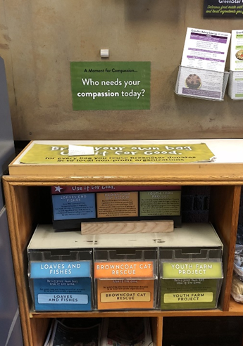
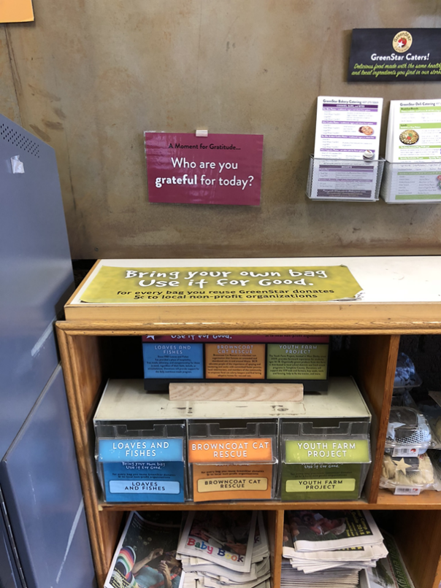
Gratitude Flyer Compassion Flyer
Flyer Post-test
Participants from MTurk (N = 100) were recruited to complete the post-test. Participants were randomly assigned to view one the two emotion flyers – Compassion or Gratitude. After viewing the flyer, participants were asked to indicate the extent to which the flyer induces a series of different emotions.

Please indicate to what extent the poster makes you feel each of the following emotions:
1: Very Slightly; 5: Extremely
Interested, Grateful, Happy, Compassionate, Calm, Enthusiastic, Proud, Thankful, Kindness, Inspired.

First, we ran a factor analysis in SPSS on all the items using Principal Axis Factoring with Promax Rotation. The items loaded onto three distinct factors. The first factor comprised of the six positive affect items (Interested, Happy, Calm, Enthusiastic, Proud, Inspired; Eigen Value = 5.89). The second factor consisted of the two gratitude items (Grateful, Thankful; Eigen Value = 1.20) and the third factor consisted of the two compassion items (Compassionate, Kindness; Eigen Value = .71).

The six generalized positive affect items were combined to form the positive affect index (α = .90). A univariate ANOVA revealed no significant effect of flyer type on positive affect (F(1, 98) = 1.73, p = .192, = .02). Hence, the flyers did not significantly differ in the level of generalized positive mood they induced. Next, we performed a univariate ANOVA with the compassion index (α = .76), as the dependent variable. The analysis revealed a significant difference between the two flyer types (F(1, 98) = 9.28, p = .003, = .09). Participants who saw the compassion flyer (M = 3.71, SD = .91) reported feeling more compassionate than those that saw the gratitude flyer (M = 3.04, SD = 1.26). Finally, another univariate ANOVA revealed a significant difference in the gratitude index (α = .87) between the text conditions (F(1, 98) = 9.67, p = .002, = .09). Participants who saw the gratitude flyer (M = 3.34, SD = 1.28) reported feeling more grateful than those that saw the compassion flyer (M = 2.60, SD = 1.09). Hence, the two flyers did not significantly differ in the level of positive affect that they induced, but they successfully evoked compassion and gratitude respectively.

WEB APPENDIX C
SUPPLEMENTARY MATERIALS FOR STUDY 2
Charity Appeal Advertisements
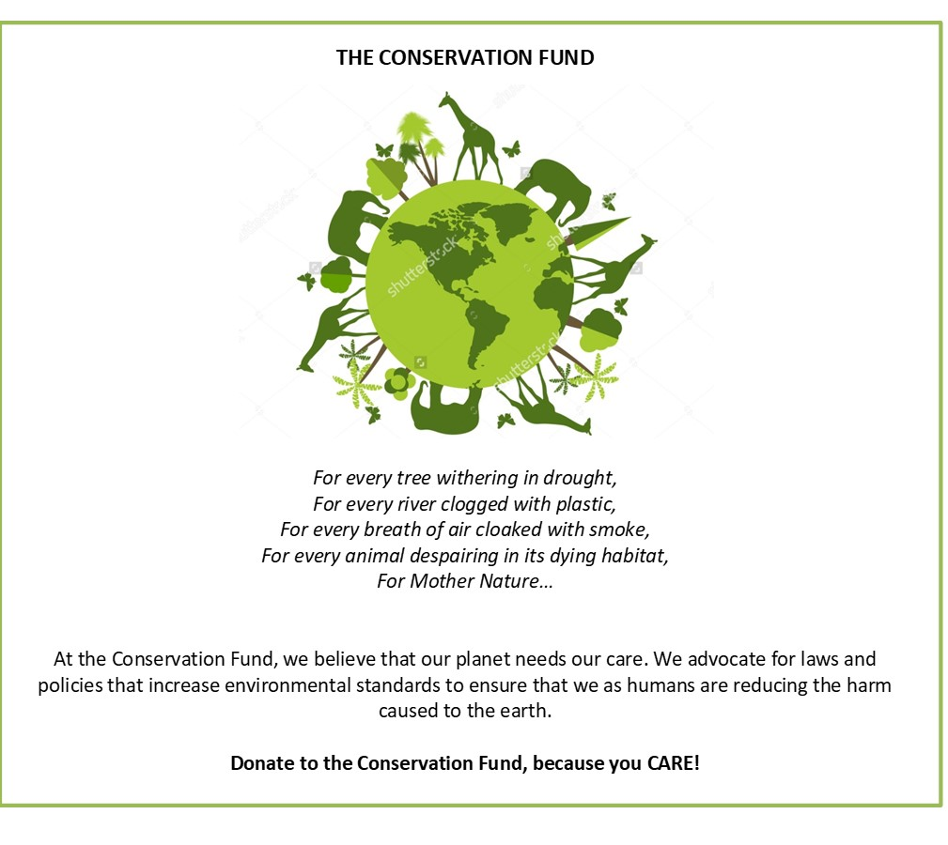
Compassion-Care
You can find out more about the charity through this link - https://www.conservationfund.org/
We appeal to you to donate a part of your $0.50 bonus payment to this charity. The amount you indicate below will be donated to the charity and the remaining amount will be given to you as a bonus. Slider Scale: $0-$0.50

Compassion-Fair
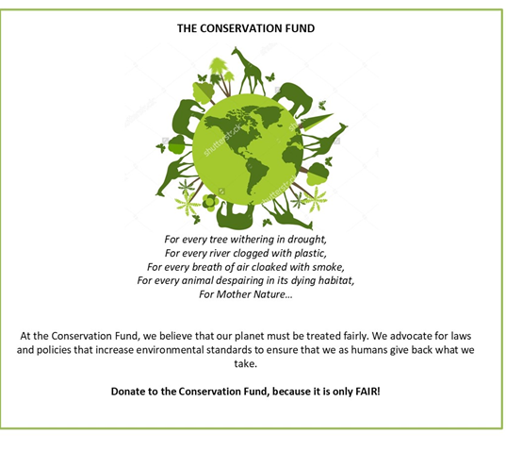
You can find out more about the charity through this link - https://www.conservationfund.org/
We appeal to you to donate a part of your $0.50 bonus payment to this charity. The amount you indicate below will be donated to the charity and the remaining amount will be given to you as a bonus. Slider Scale: $0-$0.50

Gratitude-Care
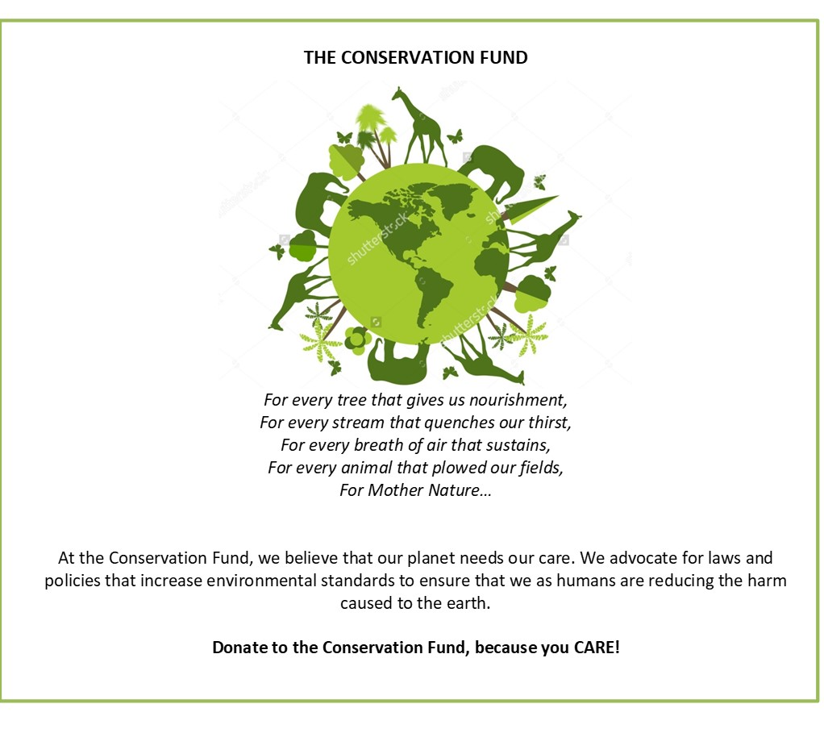

You can find out more about the charity through this link - https://www.conservationfund.org/
We appeal to you to donate a part of your $0.50 bonus payment to this charity. The amount you indicate below will be donated to the charity and the remaining amount will be given to you as a bonus. Slider Scale: $0-$0.50

Gratitude-Fair
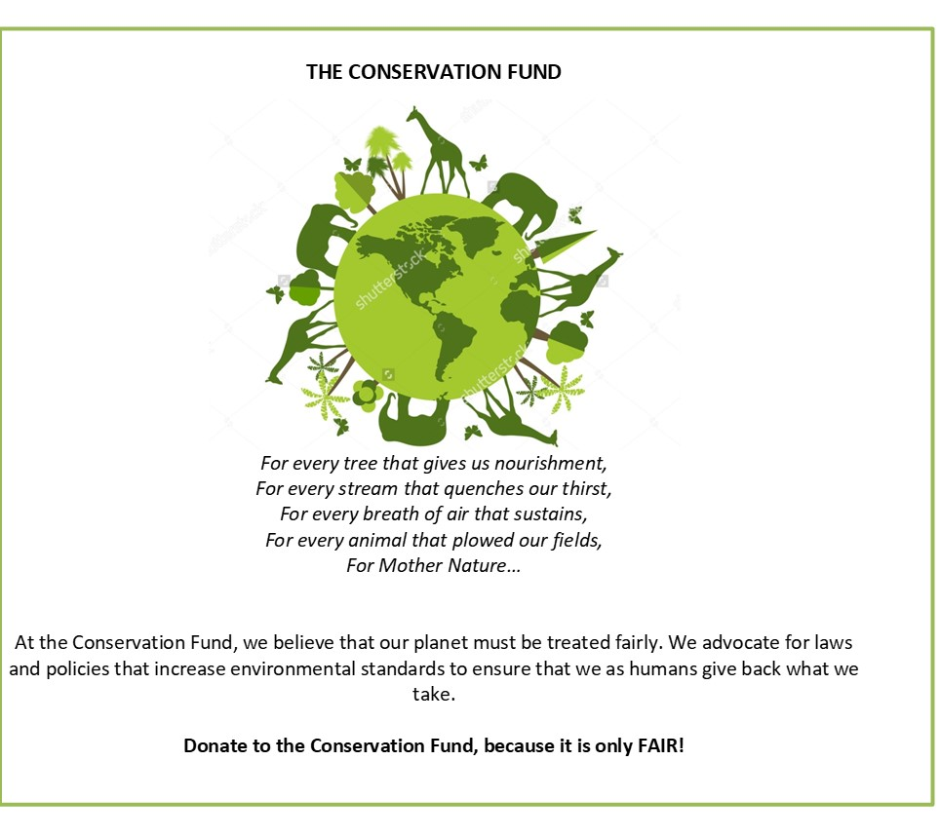
You can find out more about the charity through this link - https://www.conservationfund.org/
We appeal to you to donate a part of your $0.50 bonus payment to this charity. The amount you indicate below will be donated to the charity and the remaining amount will be given to you as a bonus. Slider Scale: $0-$0.50

Advertisement Pretest
Participants from MTurk (N = 150) were recruited to complete the pretest. Participants were told that the study was about how ‘poems’ induce emotions. We presented participants with one of the two emotion texts – compassion or gratitude.

Subjects were presented with one of the following ‘poems.’
Compassion Inducing
For every tree withering in drought,
For every river clogged with plastic,
For every breath of air cloaked with smoke,
For every animal despairing in its dying habitat,
For Mother Nature…

Gratitude Inducing
For every tree that gives us nourishment,
For every stream that quenches our thirst,
For every breath of air that sustains,
For every animal that plowed our fields,
For Mother Nature…

Then, participants indicated the extent to which the poem made them feel a range of ten different positive emotions similar to the emotion scale used in study 2.

Please indicate to what extent the passage makes you feel each of the following emotions:
1: Very Slightly; 5: Extremely
Interested, Grateful, Happy, Compassionate, Calm, Enthusiastic, Proud, Thankful, Kindness, Inspired.

The six generalized positive affect items were combined to form the positive affect index (α = .88). A univariate ANOVA revealed no significant effect of text condition on positive affect (F(1, 148) = .20, p = .653, = .00). Hence, the texts did not significantly differ in the level of generalized positive mood they induced. Next, we performed a univariate ANOVA with the compassion index (α = .65), as the dependent variable. The analysis revealed a significant difference between the two text conditions (F(1, 148) = 6.13, p = .014, = .04). Participants who read the compassion-inducing text (M = 3.40, SD = .98) reported feeling more compassionate than those that read the gratitude-inducing text (M = 2.97, SD = 1.12). Finally, another univariate ANOVA revealed a significant difference in the gratitude index (α = .92) between the text conditions (F(1, 148) = 28.55, p < .001, = .16). Participants who read the gratitude-inducing text (M = 3.57, SD = 1.23) reported feeling more grateful than those that read the compassion-inducing text (M = 2.51, SD = 1.19). Hence, the two texts did not significantly differ in the level of positive affect that they induced, but they successfully evoked compassion and gratitude respectively.

Supplementary Analysis

Zero-Inflated Poisson Regression. The manuscript reports the statistics for the interaction and the key contrasts of interest. Here we report the complete results of the zero-inflated Poisson regression model. First, we examine results for the inflation model (logit model) which assesses the probability that participants chose not to donate to the charity (i.e. 0¢ donation). We see no significant main effect of emotion (gratitude) condition (B = .28, SE = .18, Z = 1.52, p = .128), but we see a significant main effect of moral (fairness) condition on donation choice (B = .36, SE = .18, Z = 1.96, p = .050). Importantly, and as expected, we found a significant interaction between the emotion condition and the moral condition on choice to donate (B = -.73, SE = .26, Z = -2.79, p < .005). That is, the interaction between the two factors significantly predicts a reduced likelihood of donating 0¢ to the charity. Next, we report results for the full model which assesses the amount that participants chose to donate to the charity. We see a significant main effect of gratitude condition (B = -.13, SE = .02, Z = -5.54, p < .001), and a significant main effect of fairness) condition on donation amount (B = -.13, SE = .02, Z = -5.13, p < .001). Importantly, and as expected, we found a significant interaction between the emotion condition and the moral condition on donation amounts (B = .28, SE = .03, Z = 8.23, p < .001). That is, the interaction between the two factors significantly predicts a greater amount of bonus donated to the charity. We explored the interaction between the emotion condition and moral condition through a series of contrasts. In the compassion condition, we found that donations were significantly higher with the Care appeal (M = 15.55 ¢, SE = .77) than with the Fairness appeal (M = 11.91 ¢, SE = .70; Contrast = .13, SE = .02, Z = 5.13, p < .001). And, in the gratitude condition, donations were significantly higher with the Fairness appeal (M = 16.39 ¢, SE = .77) than with the Care appeal (M = 12.21 ¢, SE = .69; Contrast = .16, SE = .02, Z = 6.52, p < .001).

WEB APPENDIX D
SUPPLEMENTARY MATERIALS FOR STUDY 3
Emotion Manipulation Instructions
Happy Condition
Please recall a time you felt HAPPY. Write a short paragraph describing the experience. Explain where you were, what you did etc. Reflect on the feelings and emotions you experienced and describe them in detail.
Compassion Condition
Please recall a time you felt COMPASSIONATE. Write a short paragraph describing the experience. Explain where you were, what you did etc. Reflect on the feelings and emotions you experienced and describe them in detail.
Gratitude Condition
Please recall a time you felt GRATEFUL. Write a short paragraph describing the experience. Explain where you were, what you did etc. Reflect on the feelings and emotions you experienced and describe them in detail.

Emotion Manipulation Check
This scale consists of a number of words that describe different feelings and emotions. Read each item and then mark the appropriate answer in the space next to that word. Indicate to what extent YOU FEEL THIS WAY RIGHT NOW, that is, at this present moment.
1-Very Slightly; 5-Extremely

Interested
Grateful
Happy
Compassionate
Calm
Enthusiastic
Proud
Thankful
Kind
Inspired

First, we averaged the six generalized positive affect items to form an index (α = .89). We performed a univariate ANOVA with this index as the dependent variable and the emotion condition as the independent factor. Analysis revealed no significant effect of emotion condition on positive affect (F(2, 497) = 1.71, p = .182, = .01). Participants in the happiness condition (M = 3.36, SD = .94), compassion condition (M = 3.37, SD = 1.05), and gratitude condition (M = 3.53, SD = .87) all reported equivalent levels of positive affect. Next, we performed a mixed-factorial ANOVA with the compassion index (α = .88) and gratitude index (α = .91) as two repeated dependent variables, and the emotion condition as the independent factor. The analysis revealed a significant interaction between the emotion condition and the emotion type (F(2, 497) = 21.30, p < .001, = .08). We explored this interaction through a series of planned contrasts. Participants in the compassion condition reported feeling significantly more compassionate (M = 3.86, SD = .94) than participants in the happiness condition (M = 3.48, SD = 1.02; M_{diff} = .38, SE = .11, p = .001, 95% CI [.15, .59]) and the gratitude condition (M = 3.51, SD = 1.18; M_{diff} = .35, SE = .12, p = .003, 95% CI [.12, .58]). Crucially, participants in the compassion condition also felt significantly more compassionate than they felt grateful (M_{diff} = .34, SE = .09, p < .001, 95% CI [.17, .52]). Participants in the gratitude condition (M = 3.98, SD = 1.06) reported feeling significantly more grateful than participants in the happiness condition (M = 3.65, SD = 1.13; M_{diff} = .32, SE = .13, p = .011, 95% CI [.08, .57]) and the compassion condition (M = 3.51, SD = 1.28; M_{diff} = .46, SE = .13, p < .001, 95% CI [.21, .72]). Again crucially, participants in the gratitude condition felt significantly more grateful than they felt compassionate (M_{diff} = .47, SE = .09, p < .001, 95% CI [.29, .64]).

Donation Appeal

You will receive $1 Bonus for completing this survey.

Now, we would like to bring your attention to a fundraising drive. As you are aware, Veterans Day was recently observed across the country, and our laboratory has formed a partnership with a veterans’ charity to raise funds. Please see a brief description of the charity below

*Subjects shown either Care charity description or Fair charity description*

We appeal to you to donate a part of your $1 bonus payment to this charity. The amount you indicate below will be donated to the charity above and the remaining amount will be given to you as a bonus.

I want to donate the following amount to the charity –
Slider Scale ($0 - $1.00)

Care Charity Description

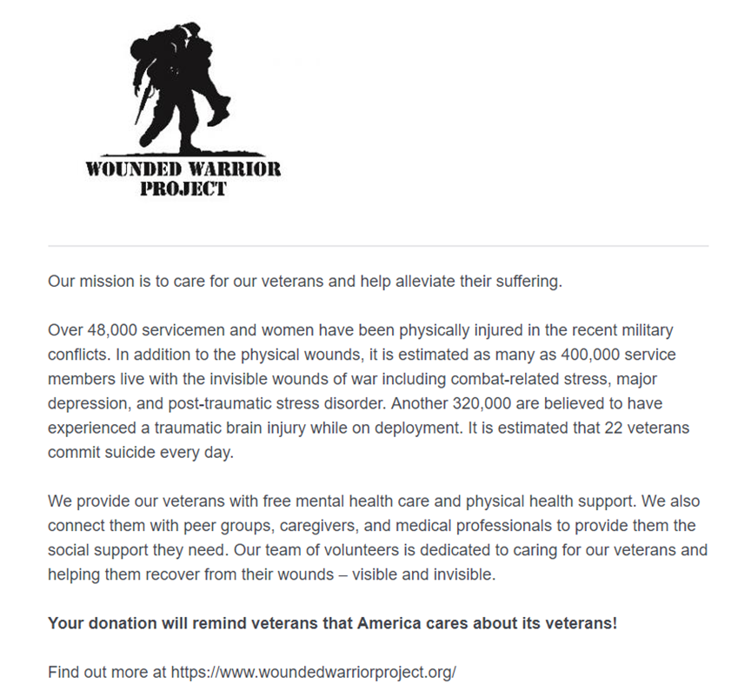

Fair Charity Description

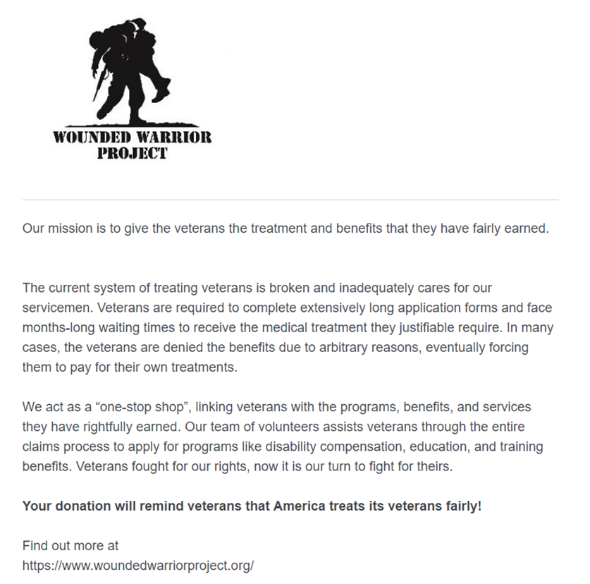

Charity Pretest

Participants from MTurk (N = 100) was recruited to complete the pretest. We presented participants with both the descriptions utilized in the main study as descriptions of two supposedly different charities.

*Subjects shown both descriptions individually in randomized order*

When donating money to the each of the charities above, to what extent does the following Moral Value apply -

Harm/Care: This charity helps alleviate suffering in the world and helps build a more caring society. (Slider Scale – 1: Not at all; 7: Extremely)

Fairness/Reciprocity: This charity helps build cooperation, fairness, or justice in the world. (Slider Scale – 1: Not at all; 7: Extremely)

Hence, each participant indicated two ratings for both the descriptions. The responses were entered into a repeated measures ANOVA with description type and moral value type as two within-subjects factors. The analysis revealed no significant main effects, but there was a significant interaction between the two factors (F(1, 99) = 52.09, p < .001, = .35). Participants associated the Care description significantly more with Care values (M = 5.47, SD = 1.54) than with Fairness values (M = 4.38, SD = 1.76; M_{diff} = 1.08, SE = .23, p < .001, 95% CI [.63, 1.55]). On the other hand, participants associated the Fairness description significantly more with Fairness values (M = 5.45, SD = 1.46) than with Care values (M = 4.32, SD = 1.73; M_{diff} = 1.13, SE = .22, p < .001, 95% CI [.69, 1.57]). Thus, the pretest confirms that the two charity descriptions represent the respective moral domains.

Supplementary Data Analysis

Zero-Inflated Poisson Regression. The manuscript reports the statistics for the interaction and the key contrasts of interest. Here we report the complete results of the zero-inflated Poisson regression model. The regression model contained a dummy variable for the compassion condition (1= compassion; 0 = otherwise) and a dummy variable for the gratitude condition (1 = gratitude, 0 = otherwise). Further, it contained a dummy variable to represent the charity moral condition (1= fairness, 0 = care). Moreover, the model contained all the relevant interactions between the dummy variables. First, we examine results for the inflation model (logit model) which assesses the probability that participants chose not to donate to the charity (i.e., $0 donation). The results are in the table below:
 | B | SE | Z | p
Compassion Dummy | -1.03 | .36 | -2.89 | .004
Gratitude Dummy | -.51 | .35 | -1.46 | .143
Moral Cond. (Fairness) | .19 | .31 | .63 | .528
Compassion * Moral Cond | .53 | .49 | 1.08 | .281
Gratitude * Moral Cond | -.2.2 | .66 | -3.35 | .001

Next, the table below reports the results for the full model which assesses the amount that participants chose to donate to the charity.
 | B | SE | Z | p
Compassion Dummy | .36 | .02 | 15.11 | <.001
Gratitude Dummy | .19 | .03 | 7.22 | <.001
Moral Cond. (Fairness) | .02 | .03 | .84 | .399
Compassion * Moral Cond | -.20 | .04 | -5.61 | <.001
Gratitude * Moral Cond | .07 | .04 | 1.90 | .057

We explored the interactions between the emotion conditions and moral condition through a series of contrasts. In the Care appeal condition, compassion (M = 55.68 ¢, SE = 2.81) evoked higher donations compared to happiness (M = 29.73 ¢, SE = 2.41; Contrast = .36, SE = .02, Z = 15.10, p < .001) and gratitude (M = 42.14 ¢, SE = 3.06; Contrast = .16, SE = .02, Z = 7.22, p < .001). Contrastingly, in the Fairness appeal condition, gratitude (M = 59.44 ¢, SE = 1.57) evoked higher donations compared to happiness (M = 28.22 ¢, SE = 2.63; Contrast = .25, SE = .02, Z = 10.57, p < .001) and compassion (M = 39.36 ¢, SD = 3.06; Contrast = .10, SE = .02, Z = 4.55, p < .001). Hence, the conjunction of the emotion and the moral domain of the charity can significantly increase prosocial donations.

We also performed another simplified version of the zero-inflated Poisson regression. This model contained a dummy variable to identify the gratitude condition (1 = gratitude; 0 = compassion), a dummy variable to identify the charity moral condition (1 = fairness, 0 = care), and the interaction between the two dummy variables. Note: that the happiness condition was omitted from this analysis. The following table reports the results of the inflate model:
 | B | SE | Z | p
Gratitude Dummy | .52 | .39 | 1.32 | .186
Moral Cond. (Fairness) | .72 | .38 | 1.89 | .058
Gratitude * Moral Cond | -2.73 | .69 | -3.93 | <.001

Next, the table below reports the results for the full model which assesses the amount that participants chose to donate to the charity.
 | B | SE | Z | p
Gratitude Dummy | -.17 | .02 | -7.22 | <.001
Moral Cond. (Fairness) | -.18 | .02 | -7.73 | <.001
Gratitude * Moral Cond | .27 | .03 | 8.33 | <.001

Finally, we also performed another simplified version of the zero-inflated Poisson regression. This model contained a dummy variable to identify the happiness condition (1 = happiness; 0 = compassion + gratitude), a dummy variable to identify the charity moral condition (1 = fairness, 0 = care), and the interaction between the two dummy variables. Note: that the compassion and gratitude conditions were combined for this analysis. The following table reports the results of the inflate model:

 | B | SE | Z | p
Happiness Dummy | .78 | .29 | 2.68 | .007
Moral Cond. (Fairness) | -.34 | .29 | -1.16 | .244
Happiness * Moral Cond | .53 | .42 | 1.26 | .209

Next, the table below reports the results for the full model which assesses the amount that participants chose to donate to the charity.

 | B | SE | Z | p
Happiness Dummy | -.29 | .02 | -13.24 | <.001
Moral Cond. (Fairness) | -.05 | .02 | -3.02 | .002
Happiness * Moral Cond | .07 | .03 | 2.22 | .026

WEB APPENDIX E
SUPPLEMENTARY MATERIALS FOR STUDY 4
Emotion Manipulation Instructions
Same as Study 3 for Compassion and Gratitude conditions.

Charity Preference
Please imagine you are going to donate $1 to a charity right now. Below are the descriptions of two veterans’ charities based in the United States.

*Subjects shown descriptions of same charities as study 3, side-by-side*

Which Charity are you more likely to donate $1 towards?
Slider Scale with end points labeled ‘Charity A’ and ‘Charity B’

Mediator
Care and Fair items taken from the Moral Foundations Questionnaire (Graham et al. 2011).

Supplementary Study with Happiness Condition and Between-Subjects Design

Whereas the results of the main study indicate that compassion and gratitude can have different relative effects on the Care and Fairness moral sub-scales, they do not demonstrate the independent effects of the two emotions. That is, does compassion increase endorsement of Care or does gratitude reduce endorsement of Care? Further, the main study also measured the moral concern sub-scales in the same participants, which may have increased the contrast between the two focal moral domains. Therefore, to demonstrate the theorized independent effects, we performed a post-test on the moral domain scales with a positive affect comparison condition in fully between-subjects design: 3(Emotion: Happiness vs. Compassion vs. Gratitude) x 2(Moral Concern Measured: Care vs. Fair). A separate pool of participants from MTurk (N = 300) was recruited in exchange for small monetary compensation. Participants were randomly assigned to one of the three emotion conditions, and emotion was induced using the same writing tasks as before. Next, half the participants were asked to complete the Care (α = .79) sub-scale of the MFQ, and half the participants were asked to complete the Fairness (α = .78) sub-scale of the MFQ. We performed a univariate ANOVA with the emotion condition and the moral scale condition as two independent factors. Analysis revealed a significant interaction between the emotion condition and moral scale type (F(2, 294) = 4.53, p = .012, = .03).
Participants in the compassion condition (M = 5.05, SD = .64) endorsed the Care sub-scale significantly more than participants in the happiness condition (M = 4.65, SD = .99; M_{diff} = .39, SE = .16, p = .014, 95% CI [.08, .71]) and the gratitude condition (M = 4.68, SD = .93; M_{diff} = .37, SE = .16, p = .023, 95% CI [.05, .68]). But there was no difference in Care endorsement between the happiness and gratitude conditions (M_{diff} = .03, SE = .15, p = .851, 95% CI [-.27, .33]). Concurrently, participants in the gratitude condition (M = 4.98, SD = .57) endorsed the Fairness sub-scale significantly more than participants in the happiness condition (M = 4.65, SD = .73; M_{diff} = .33, SE = .15, p = .026, 95% CI [.04, .63]) and the compassion condition (M = 4.67, SD = .72; M_{diff} = .32, SE = .16, p = .050, 95% CI [.00, .63]). But there was no difference in Fairness endorsement between the happiness and compassion conditions (M_{diff} = -.02, SE = .16, p = .921, 95% CI [-.33, .29]). Hence, the results of this post-test indicate that compassion and gratitude independently increase endorsement of Care and Fairness moral concerns respectively.

Supplementary Study with All Moral Domains

We recruited 200 participants from MTurk to complete the study online in exchange for small monetary compensation (M_{age} = 37.2 years, 54% female). Participants were randomly assigned to one of the two emotion conditions – Compassion or Gratitude - and given an essay writing task to evoke the desired emotion, similar to Study 3. Next, we administered an emotion manipulation check, similar to Study 3. However, in this study, we included the entire 20-item PANAS scale (Watson, Clark, and Tellegen 1988). In addition, we included two items to capture compassion and two items to capture gratitude. Importantly, we also included items to capture sympathy and empathy. Thus, we measured the extent to which participants felt the focal emotions as well as a range of other emotions. Then we administered the Moral Foundations Questionnaire. Finally, basic demographics were collected.

Emotion Manipulation Check. First, we averaged the 10 generalized positive affect items to form an index (α = .89). We performed a univariate ANOVA with this index as the dependent variable and the emotion condition as the independent factor. Analysis revealed no significant effect of emotion condition on positive affect (F(1, 198) = .66, p = .416, = .00). Participants in the compassion condition (M = 3.28, SD = .87) and gratitude condition (M = 3.18, SD = .87) reported equivalent levels of positive affect. Next, we averaged the 10 generalized negative affect items to form an index (α = .96). We performed a univariate ANOVA with this index as the dependent variable and the emotion condition as the independent factor. Analysis revealed no significant effect of emotion condition on negative affect (F(1, 198) = .35, p = .556, = .00). Participants in the compassion condition (M = 1.51, SD = .81) and gratitude condition (M = 1.58, SD = .96) reported equivalent levels of negative affect.
Then, we performed a univariate ANOVA with the sympathy measure as dependent variable and the emotion condition as the independent factor. Analysis revealed no significant effect of emotion condition on sympathy (F(1, 198) = 1.02, p = .315, = .01). Participants in the compassion condition (M = 2.88, SD = 1.09) and gratitude condition (M = 2.70, SD = 1.37) reported equivalent levels of sympathy. Then, we performed a univariate ANOVA with the empathy measure as dependent variable and the emotion condition as the independent factor. Analysis revealed no significant effect of emotion condition on empathy (F(1, 198) = .92, p = .340, = .01). Participants in the compassion condition (M = 2.87, SD = 1.11) and gratitude condition (M = 2.70, SD = 1.34) reported equivalent levels of empathy.
Next, we averaged the two compassion items to form an index (α = .81). We performed a univariate ANOVA with this index as the dependent variable and the emotion condition as the independent factor. Analysis revealed a significant effect of emotion condition on compassion (F(1, 198) = 10.90, p = .001, = .05). Participants in the compassion condition (M = 3.77, SD = .90) reported feeling more compassionate than participants in the gratitude condition (M = 3.28, SD = 1.17). Finally, we averaged the two gratitude items to form an index (α = .72). We performed a univariate ANOVA with this index as the dependent variable and the emotion condition as the independent factor. Analysis revealed a significant effect of emotion condition on gratitude (F(1, 198) = 26.22, p < .001, = .12). Participants in the gratitude condition (M = 3.44, SD = 1.14) reported feeling more grateful than participants in the compassion condition (M = 4.13, SD = .73). Hence, the emotion writing tasks did not differ in the extent to which they induced positive affect, negative affect, sympathy, or empathy. Crucially, they were successful in inducing the respective focal emotions of compassion and gratitude. Note, that even though the compassion manipulation did not evoke greater empathy and sympathy compared to the gratitude manipulation, looking at the correlations we do see that compassion has stronger correlations with both empathy (r = .42, p < .001) and sympathy (r = .46, p < .001) compared to gratitude’s correlations with empathy (r = .31, p < .001) and sympathy (r = .27, p < .001).

Moral Scales. The items for each of the five sub-scales were averaged to form the care scale (α = .73), fairness scale (α = .78), loyalty scale (α = .81), authority scale (α = .80), and purity scale (α = .86). We performed a 5 x 2 mixed measures ANOVA with the five moral scales as the dependent variables and the emotion condition as the between-subjects factor. There was a significant main effect of the moral sub-scale (F(4, 792) = 71.65, p < .001, = .27) but no main effect of emotion condition on the moral scale ratings (F(1, 198) = .01, p = .930, = .00). More importantly, there was a significant interaction between emotion condition and moral sub-scales (F(4, 792) = 8.29, p < .001, = .04). We explored the interaction through a series of planned contrasts. Means for the moral subscales are reported in the table below. We see that participants in the compassion condition endorsed the care subscale significantly more than participants in the gratitude condition (F(1, 198) = 29.42, p < .001, = .13). On the other hand, participants in the gratitude condition endorsed the fairness subscale significantly more than participants in the compassion condition (F(1, 198) = 13.68, p < .001, = .07). We see no differences in endorsement of the loyalty scale (F(1, 198) = .26, p = .613, = .00), authority scale (F(1, 198) = .00, p = .953, = .00), and purity scale (F(1, 198) = .30, p = .582, = .00).

Moral Sub-Scale | Compassion Condition | Gratitude Condition
Care | 4.86 (.66) | 4.33 (.72)
Fairness | 4.31 (.87) | 4.70 (.59)
Loyalty | 3.56 (1.05) | 3.63 (1.06)
Authority | 3.82 (1.12) | 3.83 (.97)
Purity | 3.56 (1.37) | 3.66 (1.19)
Note: Values in the table represent means for each moral domain sub-scale in the two emotion conditions. Values in brackets represent the standard deviation of the mean.

Supplementary Mediation Study with Different Moral Scales

This study was designed to provide additional support for our central theorization that compassion and gratitude evoke different moral concerns. We performed a similar mediation analysis as reported in the main manuscript, but utilized a different measure of the moral domains. We find a similar pattern of results as reported in the manuscript, that is, compassion increases endorsement of the Care moral domain, but gratitude increases endorsement of the Fairness moral domain and these moral concerns drive the preferences for the charities.
We recruited 200 participants from MTurk to complete the study online in exchange for a small monetary compensation (M_{age} = 36.77 years, 62% female). Participants were randomly assigned to one of the two emotion conditions – Compassion or Gratitude - and given an essay writing task to evoke the desired emotion. Following this, participants were presented with the same emotion manipulation check. Next, participants were introduced to the ostensibly unrelated charity evaluation study. We asked participants to imagine that they were going to donate $1.00 right now and had to choose between two veterans’ charities. We presented participants with descriptions of two charities side-by-side. These were the same descriptions utilized in Study 2 but were now labeled Charity A (Care Description) and Charity B (Fairness Description). They indicated which charity they were more willing to donate the $1.00 towards on a continuous slider scale (-3: Charity A; +3: Charity B). The initial position of the scale pointer was calibrated at the mid-point of the scale.
Then we administered the MFFS (Graham and Haidt 2012). This scale provides a separate score for each moral foundation based on the amount of money it would take to get respondents to engage in hypothetical behaviors (e.g., Care: “kick a dog in the head, hard”; Fairness: “Say no to a friend's request to help him move into a new apartment, after he helped you move the month before”). Respondents indicate their required payment for each behavior on an 8-point scale: 1 = $0 (I’d do it for free); 2 = $10; 3 = $100; 4 = $1,000; 5 = $10,000; 6 = $100,000; 7 = $1 million; and 8 = never, for any amount of money. We only administered the Care and Fairness moral-foundation subscales, each including four such payment decisions. Finally, basic demographics were collected.
Results
Emotion Manipulation Check. We averaged the six generalized positive affect items to form an index (α = .87). We then performed a univariate ANOVA with this index as the dependent variable and the emotion condition as the independent factors. Analysis again revealed no significant effect of emotion condition on positive affect (F(1, 198) = 1.32, p = .253, = .01). Hence, the emotion writing conditions of compassion (M = 3.28, SD = .85) and gratitude (M = 3.42, SD = .89) did not differ in the level of generalized positive mood they induced. Next, we performed a mixed-factorial ANOVA with the compassion index (α = .59) and the gratitude index (α = .87) as two repeated dependent variables, and the emotion condition as the independent factor. The analysis revealed a significant interaction between the emotion condition and emotion type (F(1, 198) = 60.57, p < .001, = .23). We explored this interaction through a series of individual contrasts. Participants in the compassion condition reported feeling significantly more compassionate (M = 4.04, SD = .63) than participants in the gratitude condition (M = 3.46, SD = .95; M_{diff} = .58, SE = .12, p < .001, 95% CI [.35, .81]). Participants in the compassion condition felt significantly more compassionate than they felt grateful (M_{diff} = .55, SE = .09, p < .001, 95% CI [.38, .73]). On the other hand, participants in the gratitude condition (M = 3.87, SD = .95) reported feeling significantly more grateful than participants in the compassion condition (M = 3.49, SD = 1.07; M_{diff} = .38, SE = .14, p = .008, 95% CI [.10, .66]). And, participants in the gratitude condition felt significantly more grateful than they felt compassionate (M_{diff} = .41, SE = .09, p < .001, 95% CI [.24, .58]). Hence, the compassion and gratitude writing tasks did not differ in the extent of positive affect they generated but induced the focal emotions respectively.
Mediation Analysis. To test the theory that the emotions induce different moral concerns which drive different preferences for charities, we performed a parallel mediation analysis using PROCESS Model 4 with 5000 bootstrap samples (Hayes 2013). Emotion condition was the independent variable (0= compassion, 1= gratitude), the charity preference was inputted as outcome variable (-3: Care charity; +3: Fairness charity), and the Care (α = .81) and Fairness (α = .73) subscales were used as two parallel mediators. First, we see that gratitude, compared to compassion, significantly increased endorsement of the Fairness sub-scale (B = .63, SE = .18, t = 3.44, p = .001, 95% CI [.27, .97]). However, gratitude significantly reduced endorsement of the Care sub-scale (B = -.40, SE = .16, t = -2.48, p = .014, 95% CI [-.723, -.08]), indicating that two emotions induce different moral concerns. Next, the analysis showed that gratitude compared to compassion increased preference for the Fairness charity (B = .94, SE = .29, t = 3.28, p = .001, 95% CI [.38, 1.51]), demonstrating the two emotions can result in different prosocial preferences. Further, endorsement of the Fairness sub-scale significantly increased preference for the Fairness charity (B = .51, SE = .11, t = 4.73, p < .001, 95% CI [.29, .73]). On the other hand, endorsement of the Care sub-scale significantly reduced preference for the Fairness charity (B = -.82, SE = .12, t = -6.69, p < .001, 95% CI [-1.06, -.58]). When both the moral sub-scales were included in the model, the effect of emotion condition on charity preference was no longer significant (B = .29, SE = .28, t = 1.06, p = .29, 95% CI [-.25, .83]). The mediation pathway through the Fairness sub-scale was significant (standardized indirect effect = .08 [.03, .13]). And the mediation pathway through the Care sub-scale was also significant (standardized indirect effect = .08 [.02, .14]). Hence, the endorsement of the moral foundations mediated the effect of the emotion condition on charity preference.

WEB APPENDIX F
SUPPLEMENTARY MATERIALS FOR STUDY 5

Stimuli Pretest
We recruited participants from MTurk (N = 150). Participants were assigned to one of 3(Stimuli: Control vs. Communal vs. Exchange) conditions. In control condition, participants saw the veterans charity stimuli from Study 3 with no alterations. In the Communal condition, the charity description was shown with one additional line added to the text –“ The Veterans need your help and your generosity will support the community.” In the exchange condition, the charity description was shown with the following line added to the text – “ In exchange for your donation, you will receive a branded fleece blanket”. Note, this exchange example was taken from a real veterans charity (Wounded Warrior Project), which does reward donors with a fleece blanket. Below the charity descriptions, the following measure of social norms was presented taken from (Aggarwal 2004).
Please imagine the charity above has come alive and become a person. To what extent do you feel that this charity is like:
Close Friend
Family Member
Business Person
Merchant
(1: Not at All; 7: Very Much)

The last two items were reverse scored and then all four items were averaged to from a composite scale of communal norms (α = .81). A univariate ANOVA was performed with this scale as the dependent variable and the stimuli condition as the independent factor. We found a significant effect of charity condition on this scale F(2, 147) = 7.92, p < .001, = .09). Participants in the exchange condition (M = 3.51, SD = 1.36) rated the charity to be less communal (i.e. more exchange oriented) than participants in the control condition (M = 4.48, SD = 1.44; M_{diff} = -.97, SE = .28, p < .001, 95% CI [-1.51, -.43]) and the communal condition (M = 4.43, SD = 1.29; M_{diff} = -.93, SE = .28, p < .001, 95% CI [-1.47, -.39). There was no difference in communal ratings between the control condition and the communal condition (M_{diff} = .04, SE = .27, p = .885, 95% CI [-.49, .57]). Hence, participants in control condition by default view the donations to be a communal relationship.

Emotion Manipulation Instructions
Same as Study 3 for Compassion and Gratitude conditions.

Charity Preference

Control Condition
Same veteran’s charities shown side-by-side as Study 4B
Which Charity are you more likely to donate $100 towards?
Slider Scale with end points labeled ‘Charity A’ and ‘Charity B’

Exchange Norm Condition
Same veteran’s charities shown side-by-side as Study 4B with one line added to both descriptions – ‘In exchange for the donation, the charity sends a branded fleece blanket’.
Which Charity are you more likely to donate $100 towards?
Slider Scale with end points labeled ‘Charity A’ and ‘Charity B’

WEB APPENDIX G
ALTERNATE ACCOUNT STUDY
This study was designed to test the three possible alternate accounts that might explain the effects of compassion and gratitude on prosocial behaviors. The study used a 4(Emotion: Compassion vs. Gratitude vs. Love vs. Awe) x 3(Moral Domain: Care vs. Fairness vs. Arts) x 5(Replicates) mixed design. We examined the effect of the four emotions on a variety of charities representing care and fairness moral objectives. This allows us to ascertain that the effects of the emotions are not particular to one area of charity (i.e., veterans charity or environmental charity only) or to a particular format of appeal writing (i.e., appeal requires specific words). Further, we also assessed the impact of the emotions on charities that do not represent either care or fairness moral values (i.e., arts and culture charities) to ascertain that the effects are specific to moral concerns as opposed to other drivers of prosocial behaviors. We predicted that compassion vis-à-vis all other emotions will increase donations to the charities that represent Care moral values, but gratitude vis-à-vis all other emotions will increase donations to the charities that represent Fairness moral values. Further, we predicted that the two emotions would show no difference in donations for the arts charities.

Method

We recruited 500 participants from MTurk to complete the study online in exchange for small monetary compensation (M_{age} = 36.6 years, 54.6% female). Participants were randomly assigned to one of the four emotion conditions and given an essay writing task to evoke the respective emotions, similar to Study 3. Next, all participants were shown 15 charities individually in a randomized order. Five of these charities represented Care moral values (Red Cross, American Heart Association, Feeding America, Make a Wish Foundation, Animal Welfare Institute), five of the charities represented Fairness moral values (ACLU, Times Up, Centre for Constitution Rights, Lambda Legal, Equal Justice Initiative) and five charities represented arts and culture (Intersection for the Arts, Metropolitan Museum of Art, UNESCO, World Monuments Fund, American Music Project). Participants saw the name of the charity along with a brief description of the charity’s mission. These descriptions were taken directly from the charity’s website with no alterations. Hence, the stimuli comprised of several different types of appeals and utilized different wording to make the care and fairness moral values salient. These charity descriptions were pretested to ascertain their representation of the moral domains. Further, these charity descriptions were also pretested to ensure that the text was not confounded with emotion-related words (see below). After reading each charity description, participants indicated how likely they would be to donate to this charity on a continuous slider scale (1: Not at All; 7: Extremely). Next, we measured the appraisal patterns of the emotions using standard measures taken from (Ellsworth and Smith 1988). Participants were shown the emotion essay they had previously written and asked to appraise the experience on dimensions of self-control (To what extent did you feel that you could influence what was happening in this situation? 1: Not at All; 11: Extremely) and other-agency (How responsible did you think someone/something other than yourself was for having brought about the events that there were occurring in this situation? 1: Not at All; 11: Extremely). Then, participants were asked to indicate the extent to which the emotion experience influenced social connection using three items taken from (Cavanaugh, Bettman, and Luce 2015): “to what extent did it affect the way you thought about your relationship with some individual or group; to what extent did you feel connected to another individual or group; to what extent did you feel close or closer to another individual or group (1 : Not at All; 11: Extremely).”

Emotion Manipulation Instructions
Compassion Condition
Please recall a time you felt COMPASSIONATE. Write a short paragraph describing the experience. Explain where you were, what you did etc. Reflect on the feelings and emotions you experienced and describe them in detail.

Gratitude Condition

Please recall a time you felt GRATEFUL. Write a short paragraph describing the experience. Explain where you were, what you did etc. Reflect on the feelings and emotions you experienced and describe them in detail.

Love Condition

Please recall a time you felt LOVE. Write a short paragraph describing the experience. Explain where you were, what you did etc. Reflect on the feelings and emotions you experienced and describe them in detail.

Awe Condition

Please recall a time you felt AWE. Write a short paragraph describing the experience. Explain where you were, what you did etc. Reflect on the feelings and emotions you experienced and describe them in detail.

Charity Stimuli

Participants shown 15 charity descriptions one at a time in randomized order. For each charity they answered:

How likely would you be to donate to this charity? Slider Scale (1: Not At All; 7: Extremely)
- AMERICAN RED CROSS
The American Red Cross prevents and alleviates human suffering in the face of emergencies by mobilizing the power of volunteers and the generosity of donors.​ The Red Cross, born of a desire to bring assistance without discrimination to the wounded on the battlefield, endeavors—in its international and national capacity—to prevent and alleviate human suffering wherever it may be found. Its purpose is to protect life and health and to ensure respect for the human being. It promotes mutual understanding, friendship, cooperation and lasting peace amongst all peoples.

- AMERICAN HEART ASSOCIATION
The American Heart Association is the nation’s oldest and largest voluntary organization dedicated to fighting heart disease and stroke. To improve the lives of all Americans, we provide public health education in a variety of ways. We’re the nation’s leader in CPR education training. We help people understand the importance of healthy lifestyle choices. We provide science-based treatment guidelines to healthcare professionals to help them provide quality care to their patients. We educate lawmakers, policymakers and the public as we advocate for changes to protect and improve the health of our communities.
- FEEDING AMERICA
Our mission is to feed America’s hungry through a nationwide network of member food banks and engage our country in the fight to end hunger. In a country that wastes billions of pounds of food each year, it's almost shocking that anyone in America goes hungry. Yet every day, there are millions of children and adults who do not get the meals they need to thrive. We work to get nourishing food – from farmers, manufacturers, and retailers – to people in need. At the same time, we also seek to help the people we serve build a path to a brighter, food-secure future.
- MAKE A WISH
Tens of thousands of volunteers, donors and supporters advance the Make-A-Wish® vision to grant the wish of every child diagnosed with a critical illness. In the United States and its territories, on average, a wish is granted every 34 minutes. We believe a wish experience can be a game-changer. This one belief guides us and inspires us to grant wishes that change the lives of the kids we serve.

- ANIMAL WELFARE INSTITUTE
Since its founding in 1951, AWI has sought to alleviate the suffering inflicted on animals by people. In the organization's early years, our particular emphasis was on the desperate needs of animals used for experimentation. In the decades that followed, we expanded the scope of our work to address many other areas of animal suffering. Today, one of our greatest areas of emphasis is cruel animal factories, which raise and slaughter pigs, cows, chickens and other animals. The biggest are in our country, and they are expanding worldwide.

- ACLU
For nearly 100 years, the ACLU has been our nation’s guardian of liberty, working in courts, legislatures, and communities to defend and preserve the individual rights and liberties that the Constitution and the laws of the United States guarantee everyone in this country. Whether it’s achieving full equality for LGBT people, establishing new privacy protections for our digital age of widespread government surveillance, ending mass incarceration, or preserving the right to vote or the right to have an abortion, the ACLU takes up the toughest civil liberties cases and issues to defend all people from government abuse and overreach.
- TIMES UP NOW
Powered by women, TIME’S UP addresses the systemic inequality and injustice in the workplace that have kept underrepresented groups from reaching their full potential. We partner with leading advocates for equality and safety to improve laws, employment agreements, and corporate policies; help change the face of corporate boardrooms and the C-suite; and enable more women and men to access our legal system to hold wrongdoers accountable.

- CENTER FOR CONSTITUTION RIGHTS
The Center for Constitutional Rights is dedicated to advancing and protecting the rights guaranteed by the U.S. Constitution and the Universal Declaration of Human Rights. Founded in 1966 by attorneys who represented civil rights movements in the South, CCR is a non-profit legal and educational organization committed to the creative use of law as a positive force for social change

- LAMBDA LEGAL
Founded in 1973, Lambda Legal is the oldest and largest national legal organization whose mission is to achieve full recognition of the civil rights of lesbians, gay men, bisexuals, transgender people and everyone living with HIV through impact litigation, education and public policy work.

- EQUAL JUSTICE INITIATIVE
The Equal Justice Initiative is committed to ending mass incarceration and excessive punishment in the United States, to challenging racial and economic injustice, and to protecting basic human rights for the most vulnerable people in American society.

- INTERSECTION FOR THE ARTS
Intersection for the Arts is a leading-edge arts and community development organization that connects people and communities across physical, social, cultural, and economic boundaries to instigate change. Established in 1965, Intersection's programs emphasize relationships, collaboration, and process. Intersection works with hundreds of artists through residencies, commissions, fellowships, fiscal sponsorship and incubation, performances, exhibitions, workshops and public art projects. Annually, Intersection works with more than 50 community partners across sector and field.
- METROPOLITAN MUSEUM OF ART
The Met presents over 5,000 years of art from around the world for everyone to experience and enjoy. Every member of the public, from a first-time visitor to a long-time fan, deserves an exceptional experience at The Met, and we can only deliver that with the support of our community. Your generosity enables us to present world-class exhibitions, protect our collection, offer innovative education programs, and so much more. No matter how you choose to show your support, you help us connect people to creativity, knowledge, and ideas.
- UNESCO
UNESCO works to fosters dialogue and mutual understanding among the peoples of the world. By promoting cultural heritage and the equal dignity of all cultures, UNESCO strengthens bonds among cultures. UNESCO’s fosters scientific programs and policies as platforms for development and cooperation. Serving as a laboratory of ideas, UNESCO helps countries adopt international standards and manages programs that promote cooperation, the free flow of ideas and access to quality education for all.

- WORLD MONUMENTS FUND
World Monuments Fund is a private nonprofit organization founded in 1965 by individuals concerned about the accelerating destruction of important artistic treasures throughout the world. Now celebrating 50 years, World Monuments Fund has orchestrated over 600 projects in 90 countries. Today, with affiliate organizations established in Britain, India, Peru, Portugal, and Spain — World Monuments Fund sponsors an ongoing program for the conservation of cultural heritage worldwide. The World Monuments Watch, a global program launched in 1995 on the occasion of the 30th anniversary of World Monuments Fund, aims to identify imperiled cultural heritage sites and direct financial and technical support for their preservation.
- AMERICAN MUSIC PROJECT
The American Music Project is a nonprofit organization dedicated to supporting and underwriting performances of American classical music of the past as well as selectively commissioning new works from American composers.

Charity Pretest 1: Moral Ratings

This pretest was designed to assess whether the charities represented the respective moral domains. Participants from MTurk (N = 200) were recruited to complete the pretest. We presented participants with all 15 descriptions utilized in the main study individually in randomized order. Half the participants rated the charities on care moral values and half the participants rated the charities on fairness moral values. Hence, each participant rated all charities on one moral domain only. The table below shows the mean ratings for all 15 charities.

Charity | Care Rating | Fair Rating
Care
American Heart Assc | 5.18 | 4.28
Make a Wish | 5.41 | 4.79
Animal Welfare | 5.09 | 4.55
Red Cross | 5.68 | 5.22
Feeding America | 5.70 | 5.36
Arts
American Music Project | 3.36 | 3.42
Met Museum | 3.32 | 3.63
International Arts Society | 3.38 | 3.01
UNESCO | 3.99 | 3.67
Monuments Watch | 3.29 | 3.98
Fairness
Equal Justice | 4.51 | 5.41
Lambda Legal | 4.25 | 5.18
Constitution Rights | 4.18 | 5.14
Times Up | 4.09 | 5.07
ACLU | 4.40 | 5.41

The responses were entered into a repeated measures ANOVA with charity description type as within-subjects factor and moral value rating type as between-subjects factor. The analysis revealed a significant interaction between the two factors (F(2, 392) = 31.43, p < .001, = .14). Participants associated the five Care charity descriptions significantly more with Care values (M = 5.41, SD = .91) than with Fairness values (M = 4.85, SD = 1.27; M_{diff} = .57, SE = .16, p < .001, 95% CI [.26, .87]). On the other hand, participants associated the five Fairness charity descriptions significantly more with Fairness values (M = 5.24, SD = 1.36) than with Care values (M = 4.28, SD = 1.39; M_{diff} = .95, SE = .19, p < .001, 95% CI [.57, 1.34]). However, for the five Arts charity descriptions there was no difference in Care (M = 3.47, SD = 1.39) and Fairness Ratings (M = 3.54, SD = 1.47; M_{diff} = .07, SE = .20, p = .765).

Charity Pretest 2: Confound Check

This pretest was designed to assess whether the charity text descriptions were confounded by words that could evoke emotions. A different sample of participants from MTurk (N = 100) were recruited to complete the pretest. We presented participants with all 15 descriptions utilized in the main study individually in randomized order. The participants all coded the charity description text for Compassion inducing text and Gratitude inducing text. Hence, all charity descriptions were rated to test for any possible confounds in their texts. The table below reports the means for the ratings. For all 15 charities we see no difference in compassion arousing rating compared to the gratitude arousing rating. Hence, the charity descriptions used in the main study are not confounded by the text.

Charity | Compassion Arousing | Gratitude Arousing
Care
American Heart Assc | 4.96 | 4.83
Make a Wish | 5.62 | 5.47
Animal Welfare | 5.79 | 5.95
Red Cross | 5.55 | 5.32
Feeding America | 5.50 | 5.36
Arts
American Music Project | 3.38 | 3.86
Met Museum | 3.87 | 4.00
International Arts Society | 3.67 | 3.97
UNESCO | 4.38 | 4.42
Monuments Watch | 3.86 | 3.87
Fairness
Equal Justice | 4.80 | 4.83
Lambda Legal | 4.45 | 4.46
Constitution Rights | 4.32 | 4.45
Times Up | 4.31 | 4.27
ACLU | 4.53 | 4.52
Note: No significant difference in any of the means above.

Appraisal Measures

*Participants shown their emotion essay*

Please reflect on the above experience and answer the following questions –

Self-Control: To what extent did you feel that you could influence what was happening in this situation? (1: Not at All; 11: Extremely)

Other-Agency: How responsible did you think someone/something other than yourself was for having brought about the events that there were occurring in this situation? (1: Not at All; 11: Extremely)

Social Connection Measures:
To what extent did it affect the way you thought about your relationship with some individual or group?
To what extent did you feel connected to another individual or group?
To what extent did you feel close or closer to another individual or group?
(1: Not at All; 11: Extremely)

Results

Donation Likelihood. We performed a 3 x 4 mixed ANOVA with the donation likelihood measures as the repeated measures dependent variables. The charity moral condition was the within-subjects factors, and the five charity replicates were nested within the respective charity moral conditions. The emotion condition was the between-subjects factor (see figure below). There was a significant main effect of emotion condition on donation likelihood (F(3, 496) = 3.04, p = .029, = .02) and a significant main effect of charity moral domain on donation likelihood (F(2, 992) = 84.16, p < .001, = .15). Importantly, there was a significant interaction between emotion condition and moral domain (F(6, 992) = 13.52, p < .001, = .08). We explored this interaction through a series of planned contrasts. Note, we report results by aggregating across the replicates for each charity moral condition. First, we see that donation likelihood for the arts charities did not vary across the emotion conditions (F(3, 496) = .57, p = .633, = .00). That is, participants in compassion condition (M = 3.09, SD = 1.56), gratitude condition (M = 3.29, SD = 1.43), love condition (M = 3.22, SD = 1.56), and awe condition (M = 3.07, SD = 1.51) were equally likely to donate to the arts charities. However, we see a significant difference in donation likelihood for the care charities (F(3, 496) = 12.43, p < .001, = .07). Participants in compassion condition (M = 4.83, SD = 1.38) were significantly more likely to donate to these charities compared to gratitude condition (M = 3.90, SD = 1.45; M_{diff} = .93, SE = .19, p < .001, 95% CI [.55, 1.29]), love condition (M = 3.98, SD = 1.71; M_{diff} = .85, SE = .19, p < .001, 95% CI [.47, 1.22]), and awe condition (M = 3.82, SD = 1.44; M_{diff} = 1.01, SE = .19, p < .001, 95% CI [.64, 1.38]). We also see a significant difference in donation likelihood for the fairness charities (F(3, 496) = 8.65, p < .001, = .05). Participants in the gratitude condition (M = 4.54, SD = 1.47) were significantly more likely to donate to these charities compared to the compassion condition (M = 3.64, SD = 1.77; M_{diff} = .90, SE = .21, p < .001, 95% CI [.49, 1.31]), love condition (M = 3.75, SD = 1.62; M_{diff} = .78, SE = .21, p < .001, 95% CI [.36, 1.20]), and awe condition (M = 3.60, SD = 1.77; M_{diff} = .93, SE = .21, p < .001, 95% CI [.52, 1.35]). Hence, we see that compassion increased donations to care charities but gratitude increased donations to fairness charities compared to the other emotions.

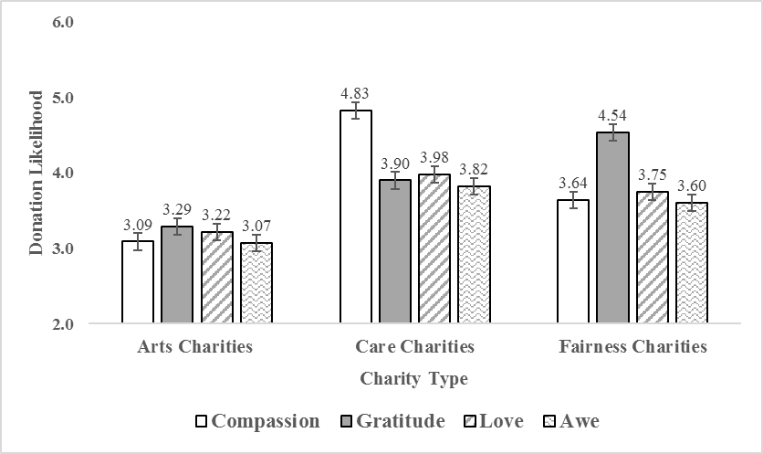
Note: Values on the vertical axis represent donation likelihood, with higher values indicating a greater likelihood of donating to the charity. The horizontal axis represents the three different charity types. Errors bars represent ± 1 SE.

Self-Control Appraisal. We performed a univariate ANOVA on the self-control appraisal measure with the emotion condition as the independent factor. We see a significant effect of emotion condition on this measure (F(3, 496) = 12.99, p < .001, = .07). Contrasts revealed that participants in compassion condition (M = 7.00, SD = 3.28) reported higher self-control appraisal compared to the gratitude condition (M = 5.98, SD = 3.15; M_{diff} = 1.02, SE = .40, p = .012, 95% CI [.22, 1.81]) and the awe condition (M = 4.63, SD = 3.20; M_{diff} = 2.37, SE = .40, p < 001, 95% CI [1.58, 3.16]). However, participants in compassion condition showed no difference in self-control appraisal compared to the love condition (M = 6.52, SD = 3.18; M_{diff} = .48, SE = .41, p = .238, 95% CI [-.32, 1.28]). Hence, compassion and love show similar appraisal patterns for self-control, but love did not increase donations to the welfare charities. Moreover, the self-control appraisals did not mediate the effect of compassion on preferences for welfare charities (standardized indirect effect = [-.01, .22]). Therefore, altogether both these results suggest that the effects of compassion on the welfare charities are not driven by the self-control appraisal.

Other-Agency Appraisal. Next, we performed a univariate ANOVA on the other-agency appraisal measure with the emotion condition as the independent factor. We again see a significant effect of emotion condition on this measure (F(3, 496) = 8.76, p < .001, = .05). Contrasts revealed that participants in the gratitude condition (M = 8.41, SD = 2.64) reported higher other-agency appraisal compared to the compassion condition (M = 6.88, SD = 3.66; M_{diff} = 1.53, SE = .39, p < .001, 95% CI [.75, 2.31]) and the love condition (M = 6.98, SD = 3.51; M_{diff} = 1.43, SE = .40, p < .001, 95% CI [.64, 2.23]). However, participants in gratitude condition showed no difference in other-agency appraisal compared to the awe condition (M = 8.33, SD = 2.66; M_{diff} = .08, SE = .39, p = .849, 95% CI [-.71, .86]). Hence, gratitude and awe show similar appraisal patterns for other-agency, but awe did not increase donations to the justice/equality charities. Moreover, the other-agency appraisals did not mediate the effect of gratitude on preferences for justice/equality charities (standardized indirect effect = [-.04, .07]). Therefore, altogether both these results suggest that the effects of gratitude on the justice/equality charities are not driven by the other-agency appraisal.

Social Connection. The three items for social connection were averaged to form a scale (α = .91). We performed a univariate ANOVA on the social connection measure with the emotion condition as the independent factor. We see a significant effect of emotion condition on this measure (F(3, 496) = 19.91, p < .001, = .11). Contrasts reveal that love (M = 9.47, SD = 1.87) motivates greater social connection compared to compassion (M = 8.37, SD = 2.03; M_{diff} = 1.09, SE = .30, p < .001, 95% CI [.51, 1.69]), gratitude (M = 8.52, SD = 2.46; M_{diff} = .95, SE = .30, p = .002, 95% CI [.35, 1.54]), and awe (M = 7.16, SD = 2.94; M_{diff} = 2.31, SE = .30, p < .001, 95% CI [1.72, 2.89]). These results replicating findings from extant research demonstrating the effects of love on social connection (Cavanaugh et al. 2015). Importantly, we see no difference in social connection between compassion and gratitude (M_{diff} = -.15, SE = .29, p = .613, 95% CI [-.74, .44]). Therefore, this suggests that the effects of compassion and gratitude on prosocial preferences cannot be explained by differences in social connection.

REFERENCES
Aggarwal, Pankaj (2004), “The Effects of Brand Relationship Norms on Consumer Attitudes and Behavior,” Journal of Consumer Research, 31(1), 87–101.
Cavanaugh, Lisa A., James R. Bettman, and Mary Frances Luce (2015), “Feeling Love and Doing More for Distant Others: Specific Positive Emotions Differentially Affect Prosocial Consumption,” Journal of Marketing Research, 52(5), 657–73.
Ellsworth, Phoebe C. and Craig A. Smith (1988), “Shades of Joy: Patterns of Appraisal Differentiating Pleasant Emotions,” Cognition and Emotion, 2(4), 301–31.
Graham, Jesse and Jonathan Haidt (2012), “Sacred Values and Evil Adversaries: A Moral Foundations Approach,” in The Social Psychology of Morality: Exploring the Causes of Good and Evil, ed. Mario. Mikulincer and Phillip R. Shaver, Washington D.C.: American Psychological Association.
Graham, Jesse, Brian A. Nosek, Jonathan Haidt, Ravi Iyer, Spassena Koleva, and Peter H. Ditto (2011), “Mapping the Moral Domain,” Journal of Personality and Social Psychology, 101(2), 366–85.
Hayes, Andrew F. (2013), Introduction to Mediation, Moderation, and Conditional Process Analysis: A Regression-Based Approach, NY: Guilford Press.
Watson, David, Lee A. Clark, and Auke Tellegen (1988), “Development and Validation of Brief Measures of Positive and Negative Affect: The PANAS Scales,” Journal of Personality and Social Psychology, 54(6), 1063–70.

